IMPLEMENTATION OF MEDIA FLASHCARDS 3 LANGUAGES (ENGLISH-INDONESIA-SAS) IN PROMOTING THE LEARNING OF OTHER LANGUAGES IN CHILDREN AGE

Heavy Nala Estriani¹, Raka Maypangestu Hidayat² Sofia Munaya Alkaff³, Revalita Amara Dwina⁴, Dalfiha Mulia Ananda⁵, Baiq Amalia Asri Aisyati⁶, Rizal Agus Pramudiansyah⁷
^{1,2,3,4,5,6,7} Department of International Relations, University of Mataram
Kkraka1705@gmail.com

ABSTRACT

Flashcards are small pieces of paper, 25 x 30 cm, that contain interesting pictures and explanations of words that match the pictures in the Flash Card. Flash cards can be said to be visual media that can provide an overview to students about the material being taught and in this study will explain the English language material taught to children in Bintaro Village, Ampenan, Lombok, West Nusa Tenggara. The Flashcard media taught to children contains pictures and words from the picture contained in 3 languages (English, Indonesian, and Sasak). The use of 3 languages in this Flash Card which contains Sasak language as the mother tongue is used to facilitate children's understanding where their mother tongue is Sasak language. The results of student learning show an increase in understanding of basic English learning, namely in cycle I the level of understanding is 35%, Cycle II 50%, Cycle III 67%, Cycle IV 83.3%.

Keywords: Flashcards, Teaching, Education, Literacy, Children.

INTRODUCTION
Foreign language education is essential for early childhood because basically, early childhood has a very high curiosity about something that has never been learned or known. One of the foreign languages that needs and is important for early childhood to learn is English. Nowadays, English is not a foreign language that can be underestimated, so many people want to learn English as an important instrument in life (Susfenti, 2021). The introduction of English in early childhood is important for parents and educators such as teachers and others because it will be related to increasing children's understanding of language and one of them is a foreign language. Of course, the introduction and teaching of foreign languages in early childhood has a way that is different from teaching foreign languages to teenagers and adults. Teaching given in early childhood is more directed towards the introduction of English by explaining the basics in English such as words of introduction, names of animals, plants, and others that are taught by playing so that the learning process can be packed with fun and easily understood by early childhood (Nasution, 2016)
Of course, early childhood education is one of the problems in an area in Mataram City, West Nusa Tenggara, namely Bintaro Jaya Neighbourhood, Bintaro Village, Ampenan District, Mataram City, NTB. Bintaro Jaya is one of the villages in the city of Mataram, West Nusa Tenggara, which is located and directly adjacent to the coastal area. Bintaro Village is divided into five neighborhoods, namely Telaga Emas, Dende Seleh, Bugis, Pondok Prasi, and Bintaro Jaya (Suryantara & Syahmat, 2022). One of the problems found in Bintaro Jaya Neighbourhood is education. This can be seen in the lack of education obtained by children in the Bintaro Jaya neighborhood while the area is still included in the city and adjacent to the tourist sector, namely Senggigi Beach. The education received by coastal children in Bintaro Jaya Neighbourhood is still lacking so it requires special attention as explained by the community that moves the Pesisi Juang School for the education of coastal children in Bintaro Jaya Neighbourhood that the education received by children is still lacking so that it makes it an urgency that needs attention because education has a very big influence on the order of society and the region in the future (Najua, 2023). In addition, the lack of understanding of foreign languages, especially English, makes it important to teach coastal children starting from an early age (Prahana, 2022).
One of the problems faced by educators at this time, especially in early childhood education, is the lack of children's interest in learning which causes children not to focus on learning and prefer to play. This is caused by a monotonous or unvaried way of learning that causes a learning process that is not cool and is more likely to emphasize academic abilities that only emphasize children's cognitive abilities such as reading, writing, and counting so that the learning received by children tends to be boring. Children need an interesting and fun learning style so that it can give a cheerful and pleasant impression to children (Mulyati, 2019). This can be the key to increasing children's interest in learning at an early age because using fun learning methods will not make children feel bored and will generate interest in children to return to learning. One method that can be used in teaching early childhood is to use the picture card method or what is called flashcards (Akmal, 2020).
Therefore, the importance of fun learning media for children because learning media is one of the instruments that has a function as a means of non-verbal communication. Learning media which is an instrument in this system component must be applied and utilised in learning (Supriyono, 2018). Fun learning activities can build student interest in learning but must involve student participation in the learning process to train children's sensors through listening, seeing, writing, feeling, and thinking about the material taught in the learning process. Thus, the presence of learning media will facilitate children's understanding of the material presented (Supriyono, 2018). Furthermore, the Ministry of Education and Culture asserts that using learning media can increase students' interest and motivation to learn in the classroom help reduce verbalism, and help arouse the reasoning and imagination of students (Supriyono, 2018).
One of the learning media used is Flash Card media. Flash Card is a small cardboard paper measuring 25 x 30 cm which contains interesting images along with explanations of words that match the images in the Flash Card (Nizam et al., 2021) Flash Card can be said to be a visual medium that can provide an overview to students about the material being taught and in this study will explain about English material taught to children in Bintaro Village, Ampenan, Lombok, West Nusa Tenggara. In the Flash card media taught to children contains pictures and words from the picture contained in 3 languages (English, Indonesian, and Sasak). The use of 3 languages in this Flash Card which contains Sasak language as the mother tongue is used to facilitate children's understanding where their mother tongue is Sasak language (Ismiani et al., 2020). The data from the children of Bintaro Jaya Village who became students and students, namely:

Table 1.1 Children's Class Data of Bintaro Village

No. | Class | Total
1. | 1 SD | 8 Children
2. | 2 SD | 6 Children
3. | 3 SD | 9 Children
4. | 4 SD | 7 Children
Total = 30 children

By using Flash Card learning media that is fun and is expected to increase students' interest in learning and level of understanding, therefore, this study will use this media which is applied to children in Bintaro Village, Ampenan, Lombok, NTB which is carried out by the Merdeka Learning Campus Merdeka group of the We6rowUp Humanitarian Project, Mataram University. The use of Sasak language contained in Flashcards is used to provide an easier understanding for Bintaro Village children they use the Sasak language as their daily language. This research will see the role of Flash Card media in introducing foreign language material, namely English. The curriculum used in the learning process was carried out within a month by going to the field 4 times, namely on 9, 16, 23, and 30 September 2023. In the first week, the material explained is material about Family, Fruit and Veggie, and Animal, and closed with a test conducted to measure the basic ability of children to English.

METODE
Time and Place
This community service activity was carried out on the coast of Bintaro Jaya neighbourhood, Ampenan sub-district, Mataram city. Starting from 9-30 September 2023.

Materials and Tools
- 3 Language Flashcards
- Notebook
- Pencils and Pens
- Coloured Pencils
- Blackboard
- Picture books (pictures of fruits and animals)

Target Activity
After discussions and coordination with Sekolah Pesisi Juang (SPJ), as the non-formal school foundation invited to work together, the target for our program is coastal children who are currently attending elementary school starting from grades 1-4, totaling 30 people.

Activity Stages
- Preparation Stage
Developing a program that started in August 2023, which involved preparing an activity proposal, applying for sponsorship with Bank NTB Syariah, Mataram City Library and Archives, Sekolah Pesisi Juang (SPJ), and coordinating with the local Village Head office.
- Implementation Stage
Implementation was carried out after the previous preparation process, namely coordination with the local government and Pesisi Juang School. The program was implemented in September with 4 field trips attended by 30 students.

DISCUSSION
Cycle 1
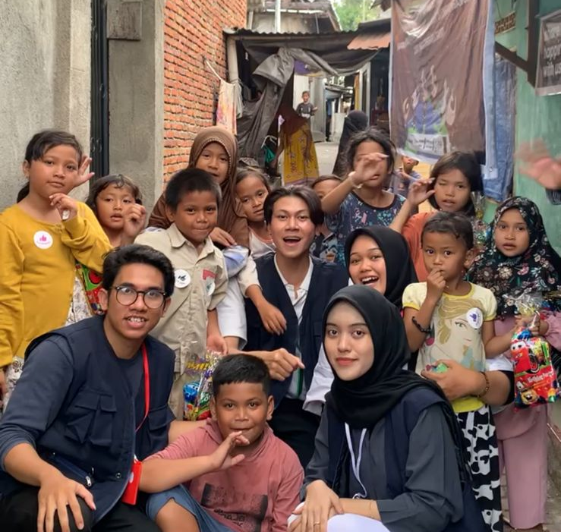
Figure 1. First meeting material about English (family)

Before the learning process, learning planning is carried out by designing a curriculum of learning materials. This curriculum design is carried out carefully by sorting out basic English learning sentences which are then translated independently into 3 languages (English, Indonesian, and Sasak). The process of preparing this curriculum lasted for one week. After compiling the curriculum as learning materials, researchers began to design 3-language flash cards with attractive images and colors. The flashcards were designed following the curriculum and divided into 3 themes of material. Each flashcard material consists of 50 objects.
The total number of children who attended classes with researchers was 30. To streamline the delivery of learning materials, the researcher divided the children into 5 study groups, each consisting of 6 children. In the first week's meeting, the children were introduced to the family in English, through the learning media of trilingual flashcards that the researcher had prepared. In the introduction of English material, the researcher acted as a teacher who delivered the material intensely to each group. Before entering the material delivery stage, the researcher tested the children's abilities by giving basic English questions related to the researcher's curriculum. This question is intended as a benchmark to determine
the extent of children's knowledge before and after getting material from the researcher's learning program.
The implementation of the class began at 16.00 by greeting the children in a friendly and pleasant manner. Researchers introduced themselves before dividing the study groups. Material delivery was carried out for 25 minutes and then continued with 5 minutes of independent learning by the students. This method is intended so that students not only listen to the material, but students can understand and be able to mention various family members in English introduced by researchers through flash cards. Furthermore, the researcher held educational games to find out the extent of the children's understanding of the material that had been delivered. This game is in the form of matching words consisting of English, Indonesian, and Sasak languages which are matched through line connections. Through this game, the researcher can find out the extent of the student's understanding of the material that has just been introduced. With this method, the researcher hopes that students can recall the materials that have been received.
In this first meeting, the researcher noted that the children still did not know English from the objects in the flash cards. The children's knowledge of English was only 5%. However, after the first lesson, the percentage of children's knowledge in English increased to 35%. This increase is known through the educational game of matching words which results in 10 children being able to answer the questions correctly.
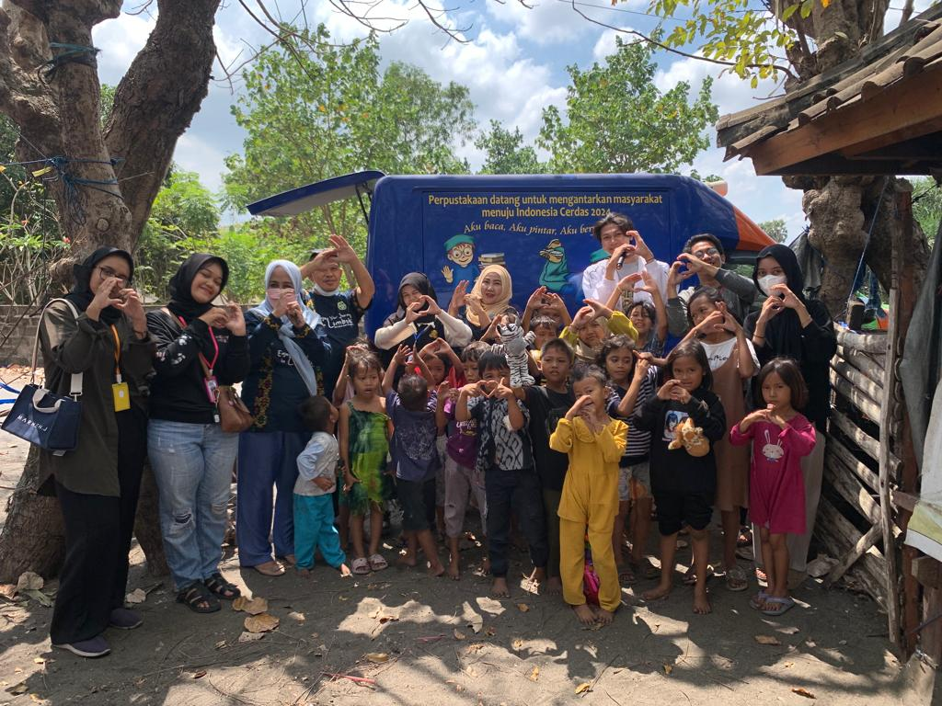
Figure 2. First activity with DIARPUS of Mataram City

In addition to carrying out learning activities in the classroom, researchers also collaborate with the Mataram City Library and Archives Office which has a mobile library program. This program is in line with the researcher's activity program which provides educational and fun reading materials for children. The implementation of the mobile library program is also equipped with early childhood toys aimed at several children aged 2-3 years who participate in activities with their parents. Some children were accompanied by their parents as a form of parental support for children's activities.
Cycle II
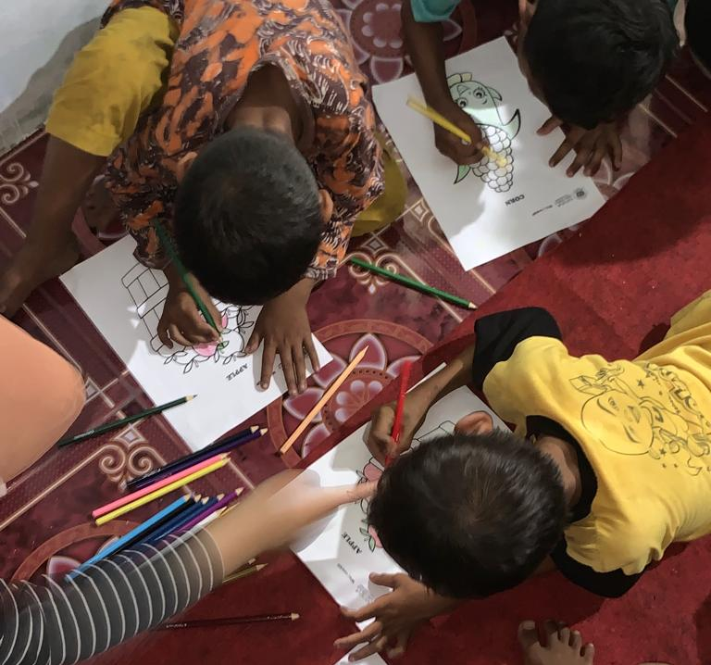
Figure 3. Second Meeting Material About English (Fruits and Vegetables)

Learning begins with the formation of groups for discussion. There were 30 students in Week 2 and they were divided into 5 groups so that there were 6 students in each group. The learning material in week 2 uses flash card learning media which is applied by the teacher in classroom learning. Teaching and learning activities are carried out at 16.00-17.30 which takes place at a non-formal school foundation called Pesisi Juang School, Bintaro Jaya neighborhood. The theme of the activities in week 2 is learning about "fruits and veggies." In this activity, the researcher acts as a teacher or teacher. The learning process is by the curriculum plan that has been prepared using flashcard media.
The implementation of learning in week 2 began with the teachers starting the learning with greetings. Then the teachers conducted brainstorming with 30 students to remember last week's learning. After that, the researchers divided the students into 5 groups. Then each group will be taught by the researchers using flash card media and introducing the theme taught in 30 minutes where in the last 5 minutes students are given independent learning time. After that, the researchers conducted a quick response quiz on the children of Bintaro Jaya Neighbourhood.
Activities are made as interesting as possible with additional games, where the games given by researchers are in the form of coloring pictures of fruits and vegetables equipped with English, this trains children's creativity and develops their imagination. The second game is in the form of guessing pictures done before the children leave the classroom, the children are required to answer the images from the Flashcards shown by the researcher, as a reward for the children's success.

During the learning process, the researchers conducted observations to determine the success of the application of flashcard media in increasing foreign language knowledge in early childhood. When viewed from the learning process of researchers and students as a whole shows a focus on process skills in learning with flash card media that makes students who are in early childhood the center, where these students are actively involved in learning.
At the end of the learning process in week 2, students were given a test to determine the level of success of flashcards in the learning that had been done. This test is in the form of guessing flashcard pictures and students try to answer the pictures in English. Based on the results of week 2 learning, shows that there is an increase in learning outcomes compared to week 1, which is an increase of around 50% where in week 2 learning the number of students who can answer is 15 children who have shown an increase from the previous week.

Cycle III
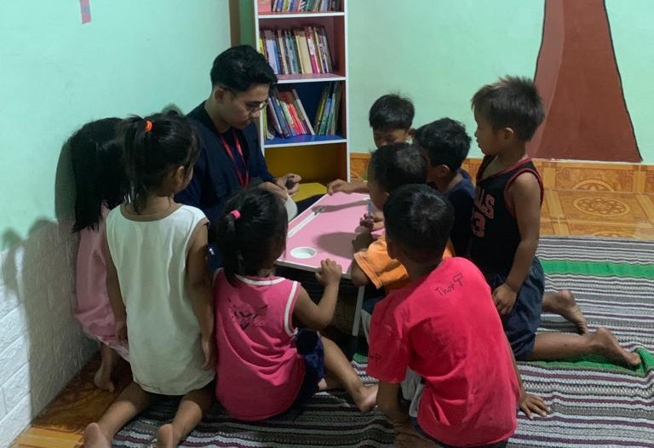
Figure 4. Third Meeting Material About English (Animals)

The theme of activities in week 3 is learning about "animals". Learning in this week is the same as the previous week, namely, learning begins with the formation of learning groups with a total of 30 students and is divided into 5 learning groups, so that each group consists of 6 children. The learning media used by the teacher in this "animals" material uses flashcards that contain pictures and 3 languages (English, Sasak, and Indonesian). Teaching and learning activities were held from 16:00-17:30 which took place at the non-formal school foundation, Sekolah Pesisi Juang, in the Bintaro Jaya neighborhood. In this activity, the researcher acts as a teacher or teacher, and the teaching and learning process is by the curriculum plan that has been prepared using flash card media.
Just like the previous weeks, learning in this 3rd cycle, the researcher started the first 15 minutes of class by testing the children's abilities and memories related to English language material in cycle 2, namely fruit and vegetable material, this week the children also showed very good progress as many as 67% of children in the class who could remember the previous material, and were enthusiastic in answering the questions given by the researcher in this 3rd week. After that, the class continued with learning the material for week three, namely recognizing the names of animals.
Learning is carried out by actively involving children, learning is carried out in groups of 5 groups where each group is accompanied by one teacher so that with this method the researcher can invite children to continue to be active in the learning process. Learning the material "animals" using the 3-language flashcard method this week was very enthusiastically welcomed by the children, they were very active and excited in guessing the names of the animals in the pictures on the flashcards, and the active learning process was carried out for 30 minutes and at the end of the learning process each of the researchers repeated the material where the children were required to guess and remember the names of the animals that had been studied.
After the active learning process is complete, the children are invited to enter the game session, namely colouring pictures of animals in which there is English from the names of these animals, this colouring activity is intended so that children can channel their creativity in choosing colours and can make children continue to be enthusiastic in learning and not feel bored in class, the colouring session is carried out for 15 minutes and 15 minutes after that it is continued with a word guessing game session, where each child before they go home, They are required to line up and guess the names of the animals addressed on the flash cards given by the examiner, if they can guess the name of the animal in English they will be given a reward by the teacher and can go home immediately, and this method is also very effective in training children's memory and making them not bored because the learning process is wrapped with various games and prizes given as a form of appreciation for their learning results that day.
This week the researchers also collaborated with the Mataram City Library and Archives Office, which this week was the second time the Mataram City Library presented a mobile library to launch the objectives of this program. The activities of the Mataram City Library this week were to invite children to read, sing, and coloring competitions together, at the end of the event there were 5 winners of the coloring competition held by the Mataram City Library and received a book prize for each winner.

Cycle IV
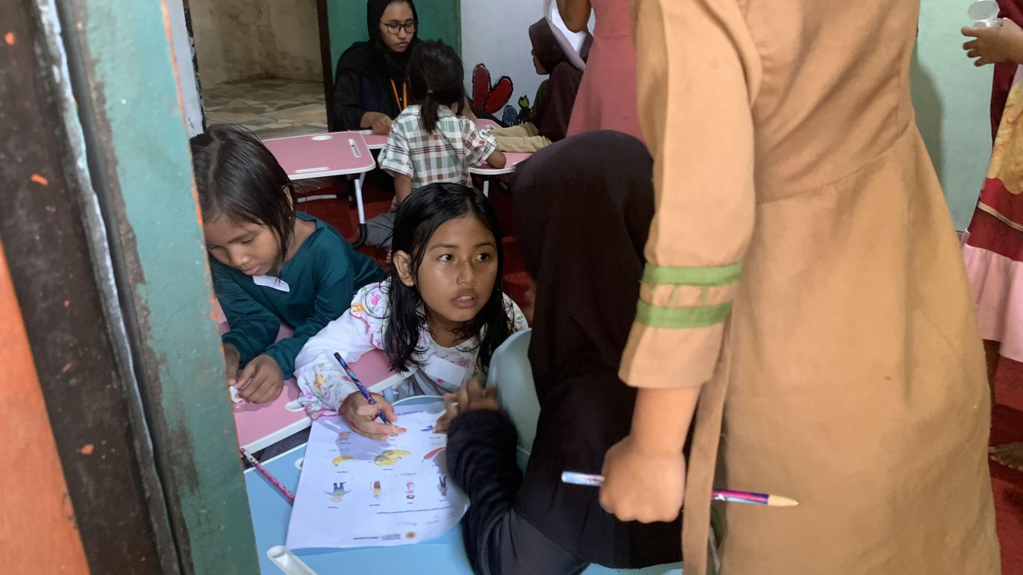
Figure 5. Fourth Meeting Conducting the Exam
In the last week, on 30 September 2023, We6rowup returned to Bintaro Jaya Village to conduct learning activities. Unlike the previous few weeks, this time the researchers returned to conduct testing activities to review the progress of students regarding the introduction of English given. The activity began with the division of discussion groups by dividing 30 children into 5 groups, each group containing six children with one person in charge (teacher).
The implementation of the exam activity was carried out by giving a sheet of exam sheet with a total of 10 questions. The form of the questions given is filled blank where the question sheet is given a picture containing material from the beginning of the meeting to the end, namely about family, fruits and vegetables, and animals. The location of the exam itself was at the Sekolah Pesisi Juang (SPJ) and the activity was attended by 30 children. In this activity, the researcher acts as a teacher. Observation activities are carried out simultaneously with the learning activities. The implementation of activities certainly takes place with the application of improvements from deficiencies or mistakes made in previous weeks so that the same mistakes do not occur. The implementation of cycle IV activities can be sequenced as follows: 1) The teacher arrived at Sekolah Pesisi Juang (SPJ) and made preparations before starting the teaching process. 2) The teacher started the meeting by greeting the students and explaining the test activities that would be carried out. 3) The teacher divided the students into 5 groups with 1 teacher in charge of each group. 4) The teacher distributes test papers to each child and gives 30 minutes to complete the test. 5) Each person in charge of the group helps guide, explain, and supervise students while working on the questions given. 6) After the time has expired, each child collects their test papers to the person in charge of their respective groups. 7) All teachers gather to give each group their test papers and start grading, 4 teachers are in charge of checking the test papers and the other 2 members are in charge of playing with the students to keep the class conducive while checking the test. 8) After the grading is complete, the teacher gives and reads out the test results of each child. 9) Before going home, the teacher distributes gifts in the form of snacks to students because they have successfully taken the exam and are willing to cooperate with the teacher during the implementation of the exam activity. 10) The teacher closes the activity by saying greetings. When viewed from the number of teacher and student activities during the exam activities, then overall teacher and student activities show student-centered learning, where students want to be actively involved in every learning activity.
Based on the researcher's notes, in cycle IV the cooperation given by students was very good, so that each student could solve the problems given individually. The data on the results of the implementation of the exam in cycle IV are as follows:
Table 2. English Exam Score Results
Value | Number of Students
50 | 2
60 | 3
70 | 2
80 | 7
90 | 9
100 | 7
From the results above, it can be seen that there was a significant improvement from the previous weeks. By setting a KKM of 70, the number of students who got a score equal to or higher than that number was 25 children out of a total of 30 children who took the exam. So the percentage of achievement produced in cycle IV is 83.3%. Although not all of them managed to reach the average score, this number is a large number of achievements so it can be said that the learning program using the flash card method applied to children at Sekolah Pesisi Juang (SPJ) has been successful. After the activities in the last week were completed, We6rowup then gave a gift in the form of a plaque and fan to Sekolah Pesisi Juang (SPJ) as a thank you to researchers for being assisted and supported while carrying out humanitarian project activities in Bintaro Jaya Village. In addition, the researchers also left flash cards (our teaching materials) in the previous weeks so that they could still be used by Bintaro children for learning purposes, to remember the materials that had previously been taught. In the future, it is hoped that the children's interest in learning and knowledge of English will increase thanks to the success of the flash card method in making learning more fun and very easy to understand because the teaching and learning process is carried out while playing. The enthusiasm of these children is expected to be maintained so that they become a smart generation, especially in mastering English.

CONCLUSIONS
The use of Flashcards as a learning media in early childhood shows success in overcoming boring teaching methods so that there is an increase in children's interest in learning which is done by learning while playing and playing while learning. Of course, this proves that there is an increase in the ability and understanding of English for coastal children in the Bintaro Jaya neighborhood, which can be seen in cycle I, only 5% could speak English, which increased to 35%, then in cycle II there was an increase to 50%, then in cycle III there was another increase from 50% to 67%, and in cycle IV there was a very significant increase in children's ability to speak English where in the previous cycle 67% increased to 83.3% so that it was noted that in each cycle there was an increase in the ability of coastal children in the Bintaro Jaya neighborhood to understand English.

REFERENCES
Akmal, A. (2020). Upaya Meningkatkan Minat Belajar Anak Melalui Pembelajaran Sains. Jurnal Pendidikan Islam Anak Usia Dini, 3, 8–17. https://journal.uir.ac.id/index.php/generasiemas/article/download/5250/2743
Najua. (2023, Agustus 13). Kondisi Pendidikan Anak-anak di Pesisir Pantai Lingkungan Bintaro jaya. (We6rowUp, Interviewer)

Nasution, S. (2016). Pentingnya Pendidikan Bahasa Inggris Pada Anak Usia Dini. Warta, 50(1), 15–19. https://jurnal.dharmawangsa.ac.id/index.php/juwarta/article/view/198
Mulyati. (2019). Menciptakan Pembelajaran Menyenangkan dalam Menumbuhkan Peminatan Anak Usia Dini Terhadap Pelajaran. Alim Journal of Islamic, I(2), 389–400. https://media.neliti.com/media/publications/362372-none-92d54ae9.pdf
Prahana, L. M. G. (2022). Komunitas Sekolah Pesisi Juang Ampenan Sentil Pemkot Mataram Soal Pendidikan Anak Pesisir. Lombok.tribunnews.com. https://lombok.tribunnews.com/2022/09/01/komunitas-sekolah-pesisi-juang-ampenan-sentil-pemkot-mataram-soal-pendidikan-anak-pesisir
Suryantara, I. M. P., & Syahmat, M. Z. (2022). Efektifitas Pelaksanaan Program Kampung Sehat Dalam Rangka Menekan Penyebaran Covid-19 (Studi Pada Kelurahan Bintaro, Kota Mataram). Jurnal Education and Development, 10(2), 125–131. https://journal.ipts.ac.id/index.php/ED/article/view/3183
Susfenti, N. E. M. (2021). Pembelajaran Bahasa Inggris Untuk Anak Usia Dini. Jurnal Studi Gender Dan Anak, 8(01), 50. https://doi.org/10.32678/jsga.v8i01.5858
Ismiani, P., Mustika, I., & Sahmini, M. (2020). Penggunaan Bahasa Ibu Dalam Keterampilan Berbicara Pada Pembelajaran Bahasa Indonesia. Parole: Jurnal Pendidikan Bahasa Dan Sastra Indonesia, 3(5 September), 767–774. https://journal.ikipsiliwangi.ac.id/index.php/parole/article/view/5373/pdf
Nizam, M., Asri, W. K., & Azizah, L. (2021). Penggunaan Media Film Dalam Penguasaan Kosakata Bahasa Jerman. Phonologie : Journal of Language and Literature, 1(2), 42. https://doi.org/10.26858/phonologie.v1i2.21514
Supriyono. (2018). Pentingnya Media Pembelajaran untuk Meningkatkan Minat Belajar Siswa SD. Jurnal Pendidikan Dasar, II(1), 43–48. https://journal.unesa.ac.id/index.php/jpd/article/view/6262

