Correlation of Sunlight Intensity and Output Voltage on Collector Plate-based Cascaded Thermoelectric Generator Modules

Mustofa
Department of Mechanical Engineering, Faculty of Engineering, Universitas Tadulako, Palu, 94118, Indonesia
email:
mustofa@untad.com
Zuryati Djafar
Department of Mechanical, Engineering, Faculty of Engineering, Universitas Hasanuddin, Gowa, 92171, Indonesia
email:
zuryatidjafar@unhas.ac.id
Abdul Halim
Department of Mechanical Engineering, Faculty of Engineering, Universitas Hasanuddin, Gowa, 92171, Indonesia
email: abdulhalim.st.13@gmail.com

Wahyu H. Piarah
Department of Mechanical, Engineering, Faculty of Engineering, Universitas Hasanuddin, Gowa, 92171, Indonesia
email: wahyupiarah@unhas.ac.id
Lita Asyriati Latif
Department of Mechanical, Engineering, Faculty of Engineering, Universitas Khairun, Ternate, 97719, Indonesia
email: lithalatif@unkhair.ac.id

Abstract – The intensity of solar energy is an important factor in viewing the performance of the thermoelectric generator (TEG). Most studies only look at the effect of treatment on the TEG module in the form of cooling mode and its materials. Therefore this study examines the effect of the solar intensity value on the magnitude of the module voltage. On the hot side of the module are placed heat absorber plates of copper, Fe and aluminum plates as well as non collector plates. Modules are cascaded and connected in series as many as 14 modules per plate, so that a total of 56 TEG modules are used. Data collection is carried out simultaneously on all plates. The test results show that the increase in solar intensity is liner with the magnitude of the TEG module voltage or in other words the correlation is positive. The data also shows that copper collector plates produce the highest voltage difference, followed by Ferro, Alumina and no-plates at ∆V 0.871, 0.805; 0.369 and 0.153 V, respectively.

Keywords: sun intensity, voltage, power output, thermal absorber
Creative Commons Attribution-NonCommercial-ShareAlike 4.0 International License.

INTRODUCTION
Solar energy has the greatest potential and is environmentally friendly as an alternative energy that humans can use to meet their daily needs for activities. One of the uses of solar light can be converted directly into electrical energy with the help of solar panel technology [1]. Besides light, the sun also carries thermal energy which can be converted by the thermoelectric generator (TEG) technology module into electrical energy [2]. Thermoelectric research is an interesting topic in view of its performance as a combination of electrical and thermal conductivity and the module material in producing voltage differences in the arrangement of the elements of the power plant [3] and [4]. The working principle of thermoelectric modules (TEMs) is fully described in the research of Pourkiaei et al.[5] which basically shows that the greater the temperature difference between the two sides of the module, the higher is the performance. Although the efficiency of the module is only about 5%, intensive studies of its performance improvement are continuing. One of the interesting things about TEM output power is the same as photovoltaic (PV) cells, namely electrical energy. So it can be said that the TEM character is similar to a solar cell, it is just that the temperature difference on both sides of the PV must be smaller [6]. In essence, PV needs photon light, while TEM prefers thermal from solar energy [7].
Many studies have been conducted to improve the performance of TEMs by varying the cooling media, so that the temperature difference on both sides increases. In other words, heat is dissipated on the cold side of the module, such as using a heatsink, fan, water jacket or simply by providing an ambient temperature above the cold side of the module to maintain a temperature difference with the hot side. The use of heat sinks to help increase heat release on the cold side thereby increasing the efficiency of the module, including [8][9] and [10]. Mahmoudinezhad et al., [10] who compared the use of an axial fan (force convection) on a heat sink mounted on the cold side of the TEM with natural convection without a fan. The results show a significant increase in the value of the output voltage and power as T increases on both sides of the module by using fan cooling, but the output voltage and power have no effect on changes in the axial speed of the fans. The maximum T obtained is 133.8°C with an output voltage and power of 16.10 V and 4.50 W respectively using an axial fan and heat sink, while without cooling it only reaches T 59.6°C, while the module voltage and power are at 7.2 V and 0.7 W. There seems to be about a 50% difference between without and with cooling. Mahmoudinezhad et al., [11] continued their research on TEMs by cooling water and adding a layer of graphite on the hot side which aims to increase the portion of the heat source absorption. The results also show a trend similar to using heat sink and fan type cooling [10].
Some of the studies above illustrate the effect of the magnitude of the temperature difference in the TEMs module on the output voltage and power. That is, the cold side of TEMs is the main treatment in terms of module performance. This study report is described comprehensively by Pourkiaei et al., [5]. The researches are rarely that describe relationship between variations in the intensity of solar energy and the treatment on the surface of the module, both on the hot and cold sides. There are some who test the effect of solar intensity with only treatment on the cold side. Among those who studied the relationship between solar or light intensity with TEG performance are [12][13][14][15] and [16]. The test investigated by Lv et al., [12] used a combination of cooling modules with heat pipes equipped with solar selective coatings inside. The highest module performance achieved was 4.8% at the noon observation point at 12.00 with a solar intensity of 930.8 W/m².
To describe in more detail the relationship between solar energy intensity and the performance of the TEMs module, further research is needed. Therefore, this experiment aims to see the correlation of solar intensity with the output voltage and power of the TEMs module in relation to the treatment on the hot side. The cold side of the module uses the same cooling mode (heat sink + fan). This will give more accurate V (Volts) and P (Watts) values under the same empirical heat source intensity conditions and the same cooling. Furthermore, to provide more varied results, a heat absorbing plate of aluminum, iron and copper was added on the hot side of the TEMs. This aims to optimize the heat absorption of the module. An initial study using 3 heat-absorbing media was carried out by Halim et al., [17]. Unfortunately, the effect of solar intensity on ∆V is not shown, only focusing on the ∆T of the module.

METHOD AND DESIGN
The design of the equipment used is shown in Figure 1. A square-shaped framework as a medium for the installation of the tool is composed of copper (Co) plates, iron (Fe) plates, and aluminum (Al) plates and non-collector plates. The absorber plates have the same thickness, which is 2 mm in rectangular shape which is placed on top of 14 TEMs modules which are cascaded and connected in series (Figure 2) on 3 types of collector plates and on no hot collector plates. So in total there are 56 thermoelectric generator modules that use a heatsink and fan cooling system. The design of the TEG modules which are cascaded and connected in series is similar to that of Kamaludin et al. [9], except that it uses a light bulb intensity source,

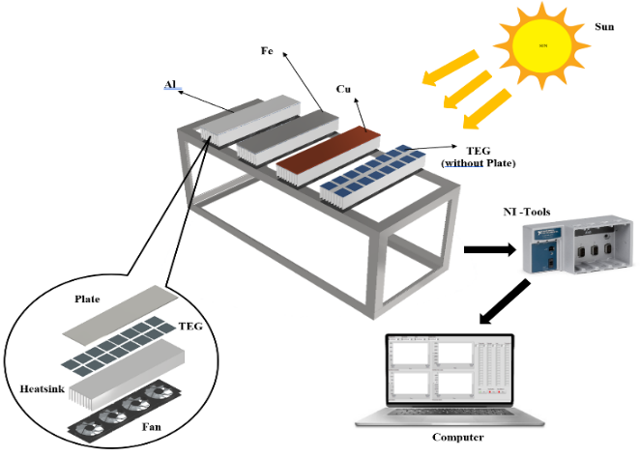

Figure 1. The scheme of Test Installation

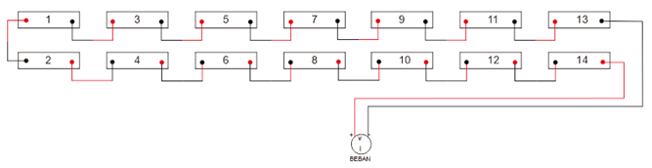

Figure 2. The Circuit of TEG Modules Electrical Series (14 TEG for each collector plate)
While in the form of a research stages flowchart can be seen in Figure 3.

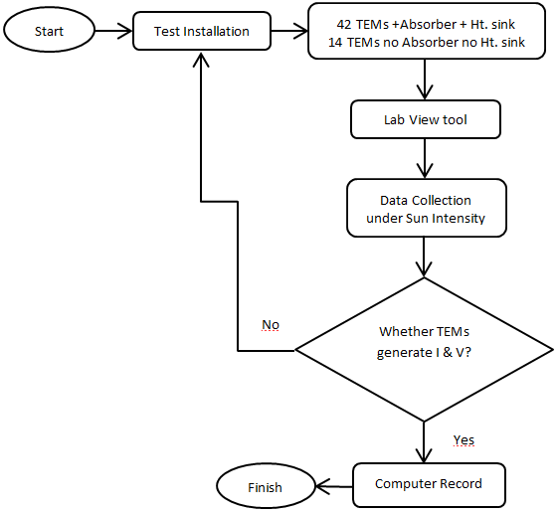

Figure 3. Flowchart of research stages

RESULTS AND DISCUSSION
Copper collector plate
Figure 4 shows that the peak ∆V reaches 0.9 V. The same pattern is shown between the increase in the electric voltage of the TEG module and the increase in solar intensity. This went on until 10.00. The voltage reaches its peak at noon at 12.00 and decreases after that until the 360th minute or 15.00 hours.
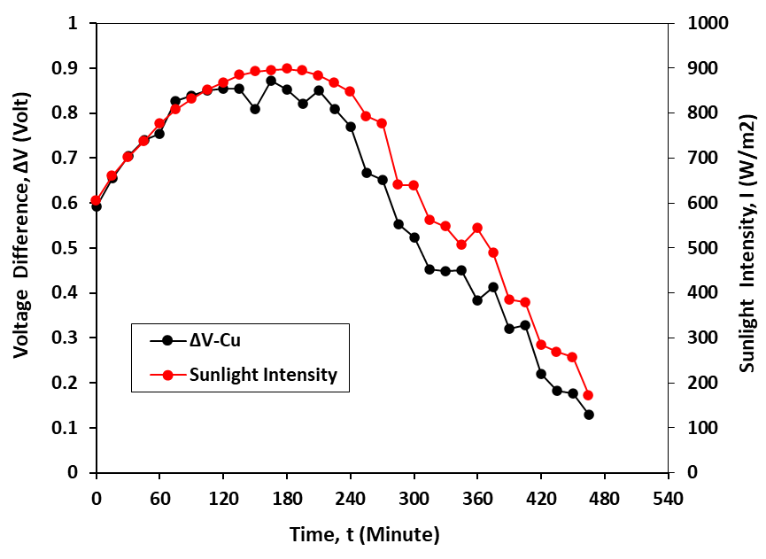
Figure 4. The pattern of changes in the voltage of the TEMs module with respect to the time of increasing solar intensity

Figure 5 shows the linear correlation between voltage and sunlight intensity using a copper collector plate with the equation ΔV = 0.0009x and the value of R² = 0.9937.

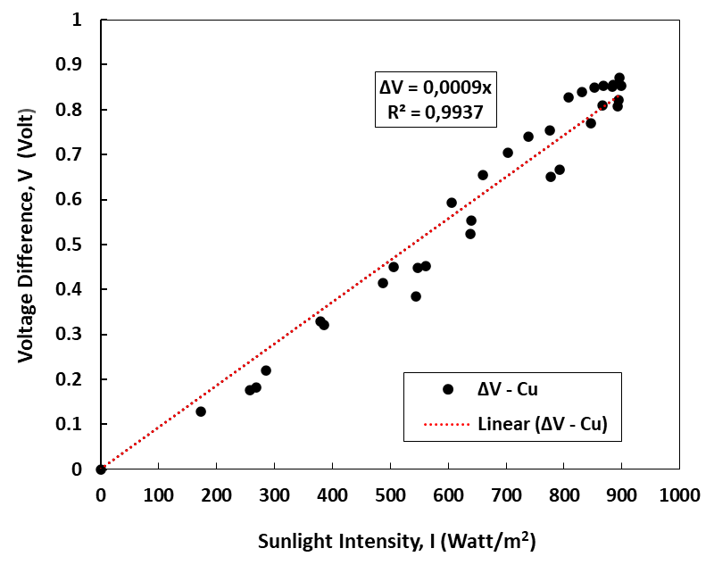

Figure 5. Linear correlation of voltage on the copper absorber TEMs module with solar intensity

Ferro Collector Plate
Figure 6 shows the voltage resulting from the intensity of the sun where data collection was carried out from 09.00 am to 17.00 pm or for 465 minutes, an increase in intensity and voltage began to occur at 10.00 or 45 minutes and decreased at 360 minutes or 15.00. The optimal ΔV is 0.8 V, lower than using a copper absorber layer.
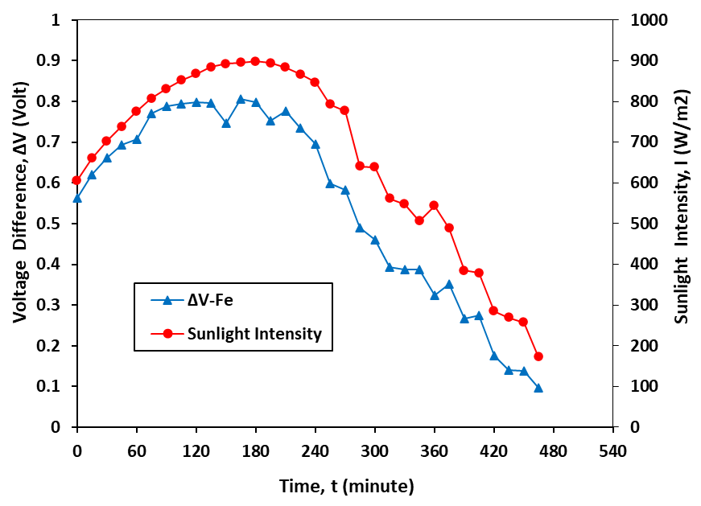
Figure 6. The pattern of changes in the voltage of the TEMs module with respect to the time of increasing solar intensity

The increase and decrease in voltage is caused by an increase and decrease in the intensity of sunlight, as the intensity of sunlight increases in Figure 7, the resulting voltage will increase. It can be seen that the resulting voltage pattern has a linear correlation with the intensity of sunlight which can be shown by the equation ΔV = 0.0009x with a value of R² = 0.9883.

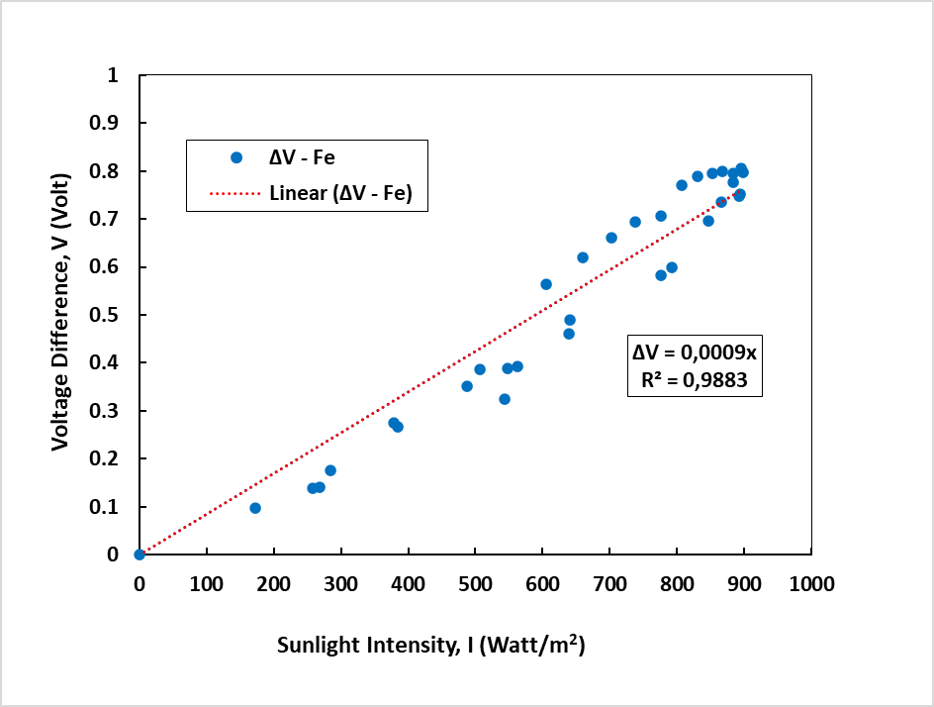

Figure 7. Linear correlation of voltage on the iron absorber TEMs module with solar intensity

Aluminum Collector Plate
Figure 8 shows the increase in voltage as the intensity of the sun increases by using an aluminum heat absorber with the same time collecting data as a copper and iron absorber. The voltage generated by the TEMs module has decreased by up to 50% compared to using a copper absorber.

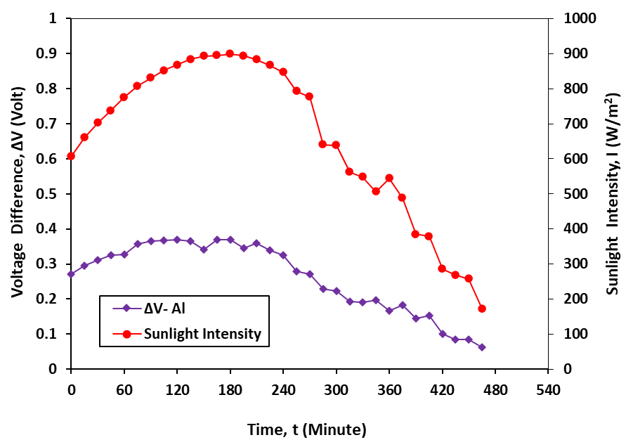
Figure 8. The pattern of changes in the voltage of the TEMs module with respect to the time of increasing solar intensity

The increase and decrease in voltage is caused by an increase and decrease in the intensity of sunlight, as the intensity of sunlight increases in Figure 9, the resulting voltage will increase. It can be seen from the pattern shown in Figure 10 that the voltage graph has a linear correlation with the intensity of sunlight which can be displayed with the equation ΔV = 0.0004x with a value of R² = 0.9924.

Figure 9. Linear correlation of voltage on the aluminum TEMs absorber module with solar intensity

The trend figures above show variations in the change in electric voltage with changes in solar intensity by using a conductor material absorber plate that has good thermal conductivity. The trend shown is in line with the research of Rahbar et al., [15] and Lv et al., [12].
In summary, the pattern of changes in the voltage on the TEMs module can be seen in Table 1.

Table 1. Comparison of voltage correlation between collector plates
Absorber material | ΔV | R²
Co  Fe  Al | 0,0009x  0,0009x  0,0004x | 0,9937  0,9883  0,9924

CONCLUSION
Based on the results of tests carried out on the collector plate with the intensity of sunlight affecting the voltage difference obtained. For testing using a solar heat collector from copper produces a voltage of 0.871 V; the iron plate generates a voltage of 0.805 V; and for aluminum plates at an output voltage of 0.153 V at the same sunlight intensity.
Likewise for the correlation resulting from the three collector plates, where the voltage correlation and regression generated between the collector plates, that is, for the Co collector plate produces ΔV 0.009x and R² 0.9937; for Fe plate ΔV 0.009x and R² 0.9883; for Al plate ΔV 0.004x and R² 0.9924.

references
[1] KESDM, "Study of the Provision and Utilization of Oil and Gas, Coal, EBT and Electricity." 2017. [Online]. Available: https://www.esdm.go.id/assets/media/content/content-kajian-penyediaan-dan-pemanfaatan-migas-batubara-ebt-dan-listrik.pdf
[2] A. A. Zainuri and A. Akbar, “Design and Construction of Thermoelectric Generator with Comparison of Sun and Water Heat Temperatures,” IOP Conf. Ser. Earth Environ. Sci., vol. 1104, no. 1, 2022, doi: 10.1088/1755-1315/1104/1/012032.
[3] A. Gürcan and G. Yakar, “Investigation of the performance of a thermoelectric generator system utilizing the thermal energy of air compressed in a compressor,” J. Korean Phys. Soc., vol. 80, no. 6, pp. 467–483, 2022, doi: 10.1007/s40042-022-00425-x.
[4] R. E. Rachmanita, C. N. Karimah, and N. Azizah, “Experimental investigations on the performance of thermoelectric generator as energy conversion system,” IOP Conf. Ser. Earth Environ. Sci., vol. 672, no. 1, 2021, doi: 10.1088/1755-1315/672/1/012103.
[5] S. M. Pourkiaei et al., “Thermoelectric cooler and thermoelectric generator devices: A review of present and potential applications, modeling and materials,” Energy, vol. 186, p. 115849, 2019, doi: 10.1016/j.energy.2019.07.179.
[6] I. Konovalov and V. Emelianov, “Hot carrier solar cell as thermoelectric device,” Energy Sci. Eng., vol. 5, no. 3, pp. 113–122, 2017, doi: 10.1002/ese3.159.
[7] Z. Djafar, A. Z. Salsabila, and W. H. Piarah, “Performance comparison between hot mirror and cold mirror as a beam splitter on photovoltaic-thermoelectric generator hybrid using labview simulator,” Int. J. Heat Technol., vol. 39, no. 5, pp. 1609–1617, 2021, doi: 10.18280/ijht.390524.
[8] R. Goswami and R. Das, “Experimental Analysis of a Novel Solar Pond Driven Thermoelectric Energy System,” no. September, 2020, doi: 10.1115/1.4047324.
[9] T. Muhtar Kamaludin, S. Awal Syahrani, W. Danny Syamsu, Basri, and Mustofa, “Experimental study of cascaded thermoelectric generators with differences in focal length using LED lights energy radiation,” IOP Conf. Ser. Mater. Sci. Eng., vol. 909, no. 1, 2020, doi: 10.1088/1757-899X/909/1/012023.
[10] S. Mahmoudinezhad, A. Rezaniakolaei, and L. A. Rosendahl, “Experimental Study on Effect of Operating Conditions on Thermoelectric Power Generation Assessing the feasibility using the , Alireza of temperature function for a long-term district heat demand forecast,” Energy Procedia, vol. 142, pp. 558–563, 2017, doi: 10.1016/j.egypro.2017.12.087.
[11] S. Mahmoudinezhad, P. A. Cotfas, D. T. Cotfas, L. A. Rosendahl, and A. Rezania, “Response of thermoelectric generators to Bi 2 Te 3 and Zn 4 Sb 3 energy harvester materials under variant solar radiation,” Renew. Energy, vol. 146, pp. 2488–2498, 2020, doi: 10.1016/j.renene.2019.08.080.
[12] S. Lv, Y. Ji, Z. Qian, Y. Pan, Y. Zhang, and W. He, “Preliminary experiment and performance evaluation of a terrestrial solar thermoelectric generators under fluctuant solar radiation,” Appl. Therm. Eng., vol. 190, no. January, p. 116753, 2021, doi: 10.1016/j.applthermaleng.2021.116753.
[13] G. Muthu, S. Thulasi, V. Dhinakaran, and T. Mothilal, “Performance of solar parabolic dish thermoelectric generator with PCM,” Mater. Today Proc., vol. 37, no. Part 2, pp. 929–933, 2020, doi: 10.1016/j.matpr.2020.06.123.
[14] Mustofa et al., “Low Sun spectrum on simulation of a thin film photovoltaic, heat absorber, and thermoelectric generator system,” Nihon Enerugi Gakkaishi/Journal Japan Inst. Energy, vol. 99, no. 8, 2020, doi: 10.3775/jie.99.88.
[15] N. Rahbar and A. Asadi, “Solar intensity measurement using a thermoelectric module ; experimental study and mathematical modeling,” Energy Convers. Manag., vol. 129, pp. 344–353, 2016, doi: 10.1016/j.enconman.2016.10.007.
[16] W. H. Piarah, Z. Djafar, Hariyanto, and Mustofa, “A new simulation of photovoltaic and thermoelectric generator hybrid system with a beam splitter cold and hot mirror for low intensity,” Int. Rev. Mech. Eng., vol. 13, no. 9, 2019, doi: 10.15866/ireme.v13i9.17884.
[17] A. Halim, Z. Djafar, and W. H. Piarah, “Enhancing Solar Power Harvest By Using Absorber Plates on Thermoelectric Generator,” pp. 53–59, 2023.

